Assignment 8- Retail Chain

Submitted by: Hammad Muniem

**Objective:** The objective of this exercise is to check the effectiveness of different marketing promotions and guaging the factors that effect sales, units and HHS.

**Exploratory Data Analysis:**

**SPEND**

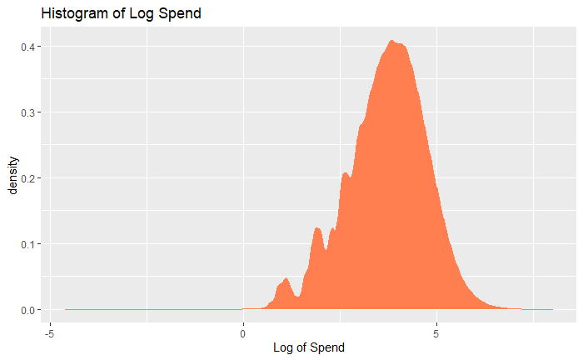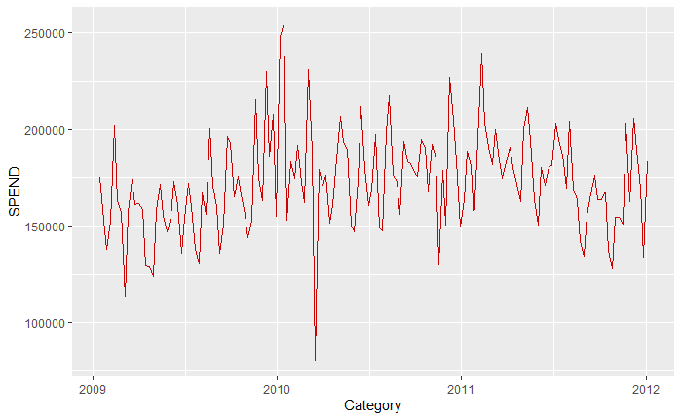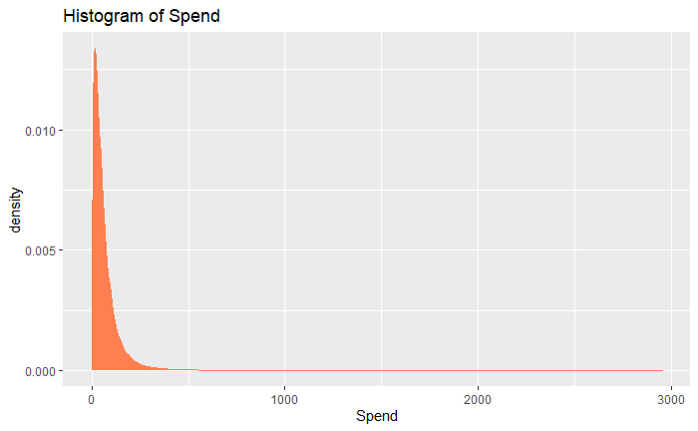

We can see that there is some seasonality in the spend data so that must be incorporated. The distribution suggests that modeling log(spend) would yield better results since the distribution is relatively normal.

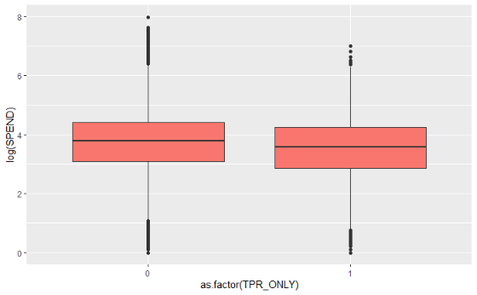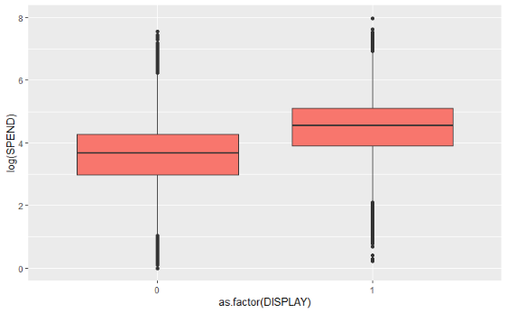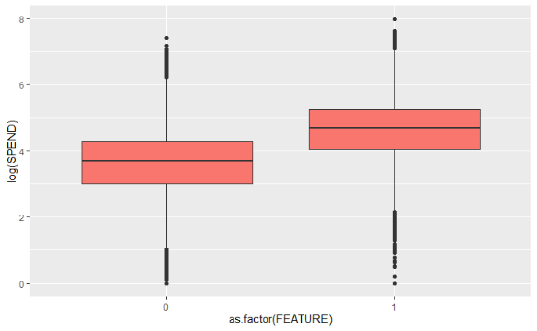

We can also see that the promotions seem to work in increasing spend except for TPR only but that needs more investigation.

**The same trend that is being observed in Spend was also observed in HHS and Units with relevant visualizations. They are not being posted here to reduce clutter.**

**The hypothesized effects are listed down for predicting all 3 (Spend, units, HHS):**

|  |  |  |
| --- | --- | --- |
| Predictor Variable | Expected sign of effect | Rationale |
| Feature | + | Since it was featured in the store circular, then we can guess that there might be some people walking in the store to purchase that specific item. So overall spend, units and HHS should be higher if a product is featured. |
| Display | + | Since it was featured in the store display, it would easily enter the consideration set of customers. So there are chances that overall spend, units and HHS should be higher if a product is featured. |
| TPR only | + | Since it was not advertised, Spend, units and HHS would not be higher than that of feature and display, but it should still be higher than not having the price reduction. |
| Year | + | As year progresses, chances are that the 3 variables would increase because of economic growth of the store and of the customers as well. |
| Month | Both | We expect some months like the holiday months to have higher spend, units and HHS because people would be shopping for that specific holiday. |
| Week of month | Both | We expect the 2nd week and 1st week of the month to have higher sales because of payment periods by companies would affect purchase power of the customer. |
| Segment | Both | We expect upscale stores to have higher spend, HHS and units because they have the perception of better quality and have higher prices. Moreover, people with more purchase power would be going there so their spending would probably be more. |
| Category | Both | We expect cold cereal category to have higher spend because compared to the other categories it is a breakfast item which makes it a bit more irreplaceable. |
| Discount | + | We expect discounted products to sell more because of customers perceiving more value while purchasing. This would have more effect on units and HHS but less on spend since spend is a function of price. |
| Price | - | We expect higher prices to reduce the number of units purchased because the same item might be available for cheaper at another store and since these are all snacking products, they might have competition in the snacking industry, so the customer would purchase something else. This would lower HHS and Spend as well. |
| State | Both | States might differ based on snacking habits. |
| Store name  (random ef) | Both | There would still be unexplained variation between the stores due to store location, service etc. that we do not have data for. |
| Product (random ef) | Both | There would still be unexplained variation between the products due to quality, taste etc. that we do not have data for. |

Other variables were not included because their derived values are taken or their variation is absorbed in the random effects.

**Models:**

**Spend**

reg<-lmer(formula = log(SPEND)~FEATURE+TPR_ONLY+DISPLAY+year+month+week+SEGMENT+STATE+(1|Product)+CATEGORY+discount+CATEGORY*FEATURE+CATEGORY*DISPLAY+CATEGORY*TPR_ONLY+SEGMENT*FEATURE+SEGMENT*DISPLAY+SEGMENT*TPR_ONLY+(1|STORE_NAME)+PRICE,data=df)

**HHS**

reg2<-lmer(formula = log(HHS)~FEATURE+TPR_ONLY+DISPLAY+year+month+week+SEGMENT+STATE+(1|Product)+CATEGORY+discount+CATEGORY*FEATURE+CATEGORY*DISPLAY+CATEGORY*TPR_ONLY+(1|STORE_NAME)+SEGMENT*FEATURE+SEGMENT*DISPLAY+SEGMENT*TPR_ONLY+PRICE,data=df)

**Units**

reg3<-lmer(formula = log(UNITS)~FEATURE+TPR_ONLY+DISPLAY+year+month+week+SEGMENT+STATE+(1|Product)+CATEGORY+discount+CATEGORY*FEATURE+CATEGORY*DISPLAY+CATEGORY*TPR_ONLY+(1|STORE_NAME)+SEGMENT*FEATURE+SEGMENT*DISPLAY+SEGMENT*TPR_ONLY+HHS+PRICE,data=df)

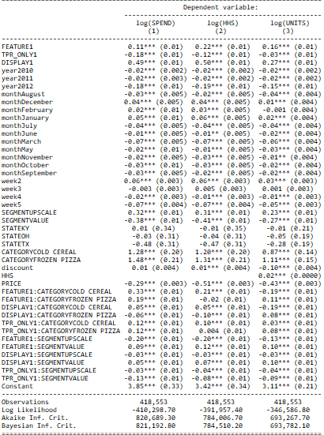

|  |  |  |  |
| --- | --- | --- | --- |
|  | **Promotion** | | |
| **Variable** | **Feature** | **Display** | **TPR Only** |
| **Spend** | Spend increases by 11% if there is a feature promotion. | Spend increases by 49% if there is a display promotion. | Spend decreases by 18% if there is a price reduction with no advertisement. |
| **HHS** | HHS increases by 22% if there is a feature promotion. | HHS increases by 50% if there is a feature promotion. | HHS decreases by 12% if there is a feature promotion. |
| **Units** | Units increases by 16% if there is a feature promotion. | Units increases by 27% if there is a feature promotion. | Units decreases by 3% if there is a feature promotion. |

1. Keeping all other factors constant, the effects of the promotions are as follows:
2. Aside from the effects mentioned above, the way promotions work would also depend on other factors such as category of products and the type of store.

|  |  |  |  |
| --- | --- | --- | --- |
|  | **Promotion** | | |
| **Variable** | **Feature** | **Display** | **TPR Only** |
| **Spend** | Spend increases by 11% if there is a feature promotion. | Spend increases by 49% if there is a display promotion. | Spend decreases by 18% if there is a price reduction with no advertisement. |
| **HHS** | HHS increases by 22% if there is a feature promotion. | HHS increases by 50% if there is a feature promotion. | HHS decreases by 12% if there is a feature promotion. |
| **Units** | Units increases by 16% if there is a feature promotion. | Units increases by 27% if there is a feature promotion. | Units decreases by 3% if there is a feature promotion. |

**SPEND**

All effects are written while keeping all other factors constant aside from the factors explored.

|  |  |  |  |  |
| --- | --- | --- | --- | --- |
| **% change in Spend** | | **Categories** | | |
| **Promotion** | **Segments** | **Cold Cereal** | **Frozen Pizza** | **Bagged Snacks** |
| **Feature** | **Mainstream** | 44% increase | 30% increase | 11% increase |
| **Value** | 53% increase | 39% increase | 20% increase |
| **Upscale** | 24% increase | 10% increase | 9% decrease |
| **Display** | **Mainstream** | 54% increase | 43% increase | 49% increase |
| **Value** | 59% increase | 48% increase | 54% increase |
| **Upscale** | 51% increase | 40% increase | 46% increase |
| **TPR Only** | **Mainstream** | 6% decrease | 6% decrease | 18% decrease |
| **Value** | 19% decrease | 19% decrease | 31% decrease |
| **Upscale** | 9% decrease | 9% decrease | 21% decrease |

**HHS**

All effects are written while keeping all other factors constant aside from the factors explored.

|  |  |  |  |  |
| --- | --- | --- | --- | --- |
| **% change in HHS** | | **Categories** | | |
| **Promotion** | **Segments** | **Cold Cereal** | **Frozen Pizza** | **Bagged Snacks** |
| **Feature** | **Mainstream** | 43% increase | 20% increase | 22% increase |
| **Value** | 55% increase | 32% increase | 34% increase |
| **Upscale** | 23% increase | No change | 2% increase |
| **Display** | **Mainstream** | 55% increase | 40% increase | 50% increase |
| **Value** | 62% increase | 47% increase | 57% increase |
| **Upscale** | 52% increase | 37% increase | 47% increase |
| **TPR Only** | **Mainstream** | 2% increase | 12.4% decrease | 12% decrease |
| **Value** | 6% decrease | 20.4% decrease | 20% decrease |
| **Upscale** | 2% decrease | 16.4% decrease | 16% decrease |

**Units**

All effects are written while keeping all other factors constant aside from the factors explored.

|  |  |  |  |  |
| --- | --- | --- | --- | --- |
| **% change in Units** | | **Categories** | | |
| **Promotion** | **Segments** | **Cold Cereal** | **Frozen Pizza** | **Bagged Snacks** |
| **Feature** | **Mainstream** | 3% decrease | 37% increase | 16% increase |
| **Value** | 7% increase | 47% increase | 26% increase |
| **Upscale** | 16% decrease | 24% increase | 3% increase |
| **Display** | **Mainstream** | 8% increase | 35% increase | 27% increase |
| **Value** | 18% increase | 45% increase | 37% increase |
| **Upscale** | 5% increase | 32% increase | 24% increase |
| **TPR Only** | **Mainstream** | No change | 5% increase | 3% decrease |
| **Value** | 9% decrease | 4% decrease | 12% decrease |
| **Upscale** | 4% decrease | 1% increase | 7% decrease |

1. The model that I ran was an interaction of price and Product name with Units as the dependent variable. The model output would not be that helpful here since it did not account for mean price and mean number of sales of each product. So I have summarized the findings below:

The most price elastic items are as follows:

|  |  |
| --- | --- |
| **Product** | **Price Elasticity** |
| NWMN OWN SUPREME PIZZA_14.7 OZ | 5.409 |
| FRSC 4 CHEESE PIZZA_26.11 OZ | 3.749 |
| NWMN OWN 4 CHEESE PIZZA_13.3 OZ | 3.68 |
| NWMN OWN PEPPERONI PIZZA_13.2 OZ | 3.316 |
| PL TWIST PRETZELS_15 OZ | 2.293 |

The least price elastic items are:

|  |  |
| --- | --- |
| **Product** | **Price Elasticity** |
| SHURGD MINI PRETZELS_16 OZ | 0.283 |
| SHURGD PRETZEL STICKS_16 OZ | 0.266 |
| PL RAISIN BRAN_20 OZ | 0.017 |
| SNYDR FF MINI PRETZELS_16 OZ | -0.072 |
| SNYDR SOURDOUGH NIBBLERS_16 OZ | -0.226 |

1. If the goal was to increase unit sales, then price should be decreased of products with high elasticity like

* nwmn own supreme pizza_14.7 oz
* frsc 4 cheese pizza_26.11 oz
* nwmn own 4 cheese pizza_13.3 oz.
* nwmn own pepperoni pizza_13.2 oz
* pl twist pretzels_15 oz

If the goal is to increase total spend, then price should be increased of products that have a low-price elasticity. This is because, if price increases, then their units don’t decrease as much so the result would be getting a higher spend.

* SHURGD MINI PRETZELS_16 OZ
* SHURGD PRETZEL STICKS_16 OZ
* PL RAISIN BRAN_20 OZ
* SNYDR FF MINI PRETZELS_16 OZ
* SNYDR SOURDOUGH NIBBLERS_16 OZ